ITDI110 – Object-Oriented Programming & Software Development.

Groupe Name: Georges TAUANEARU & Kenny DONNA

Checkpoint 1 – Requirements Analysis & OOP System Design

Project: Online Job Application & Recruitment System.

Problem description
Many companies still handle job applications in a slow and messy way — using paper forms, emails, or spreadsheets. This makes it hard to keep track of applicants, job postings, and interview schedules. Applicants often don’t know the status of their application, and HR staff spend too much time organizing everything manually. As a result, recruitment processes are often inefficient, due to manual handling of job applications, candidate shortlisting, and interview scheduling. This leads to delays, miscommunication, and difficulty tracking applicant progress.
Our system aims to digitize and streamline recruitment workflows. An online recruitment system solves this by putting everything in one place: job vacancies issued by the Human resource manager and configured to be available online within a certain period of time. This will allow the job seekers to apply online. The applicants apply to the job vacancies online by filling in the Application form online and submitting the job application requirements Softcopy of (1-Personal Information: National ID Card, Birth Certificate, Passport, Medical Report, 2-Qualification Information: Tertiary Certificate, Diploma, Degree, Master, Doctorate, 3-Curriculum Vitae: Updated version of CV, 4-Referee: Reference Letter from previous employer administrator and approved community authorities.
The system also generates a benchmarking scheme to allow each job applications to be assessed with allocated marks. The system ranks the highest to the lowest the results of job applications. And provide the names of the first for example 5 or 10 best candidates for the interview process, interview scheduling, and status updates. It makes the hiring process faster, clearer, and easier for both applicants and HR staff.

Project objectives
- Provide a browser-based platform for job seekers to apply online and recruitment.
- Enable HR/admin users to post job vacancies and manage applications.
- Allow applicants to submit applications and track their application status. (Submitted, shortlisted, interviewed, hired, rejected)
- Support interview scheduling and candidate shortlisting.
- Ensure secure and organized storage of applicant data.
- Improve efficiency and transparency in recruitment.
- Coordinate score of application based on agreed scoring rubrics (to be determined)
- Coordinate score of interviews based on application content (to be determined)
- Communicate update of the process to the candidate
- Coordinate interviewees and interviewers in a consensus manner
- Coordinate recruitment board to deliver the final decision to the applicant
- Coordinate communication of the final decision to the applicant

Target users
  - Job Seekers (students, graduates, professionals)
  - HR/Admin Staff (recruiters, interviewers, hiring managers)
  - Organizations (companies, institutions)

Minimum 6 functional requirements
- Job posting - Recruiters can create, edit, and delete job vacancies
- Application submission – Applicants can apply online via forms
- Application tracking – System updates and displays application status
- Interview scheduling – Recruiters can schedule interviews and notify applicants
- Candidate shortlisting – Recruiters can filter and shortlist candidates.
- Search functionality – Recruiters can search applicants by name, skills, or status.

Identification of the main classes/objects

- User (base class)
- Properties: userid: number; name: string, email: string
- Methods: login(), logout()
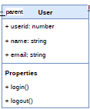

- Applicant (extends User)
- Properties: applicantid : number ;resume : private-string, phone: number
- Methods: getNationalID(), getPassport(), getBirthCertificate, getDiploma(), getBachelor(), getMaster(), getReferee(), submitapplication().
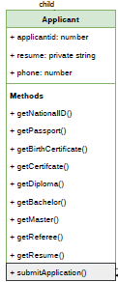

- Human Resource Staff (extends User)
- Properties: hrid : number, name : string, email: string.
- Methods: createJobVacancy(), updateJobVacany(), publishJobVacancy(), deleteJobVacancy, displayJobVacancy(), extendJobVacancy(), republishJobVacancy()
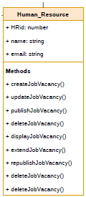

- JobVacancy(base class)
- Properties: jobVacncyID : number, company: string, jobtitle: string; jobdescription : text, responsabilities: text, qualification: string, skills: string, salary: number, benefits: string, work_location: string, app_instruction: string, startdate: date, enddate: date.
- Methods: displayjvdashboard(), approvejvdashboard(), createjvscoresheet(), displayjvonline(), applyjobvacancy(), removejvonline()
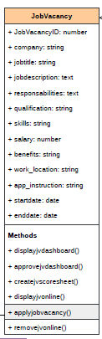

- Application
- Properties: applicationId: number, jobvacancyid: number, applicantid: number.
- Methods: registerapplication(), storeapplication(), countapplication(), scuritunizeapplication(), countapplication().
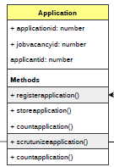
- Recruiter
- Properties: recruiterid : number, position: string, phone: number.
- Methods: getNationalIDvalid(), getPassportvalid(), getBirthCertificatevalid(), getCertificatevalid(), getDiplomavalid(), getBachelorvalid(), getMastervalid(), getrefereevalid(), scrutunizeapplication().
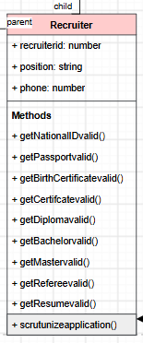

UML Class Diagram
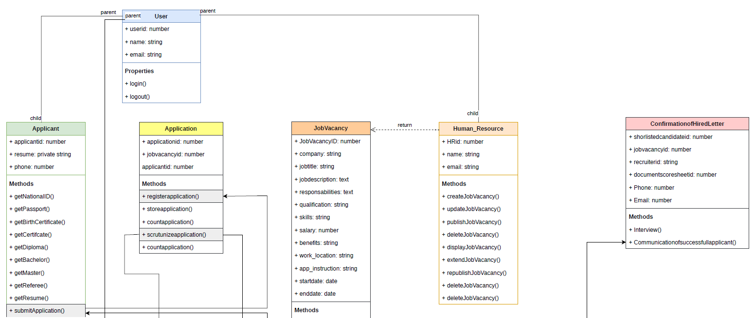

A missing part is to be inserted here please refer to the pdf file for clarification!

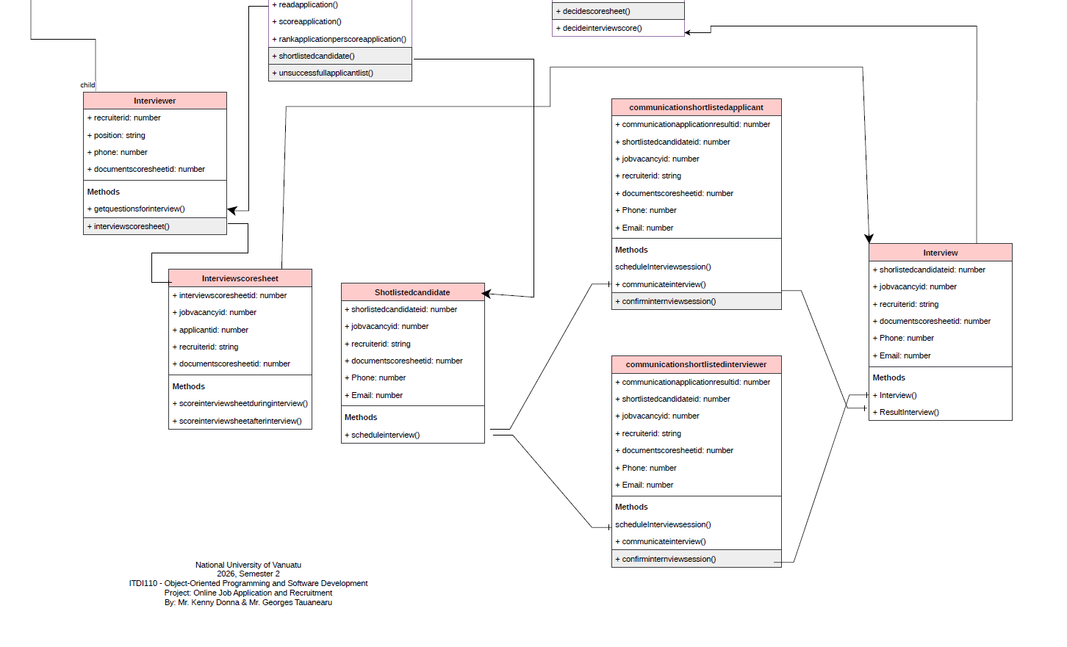

At least one inheritance relationship

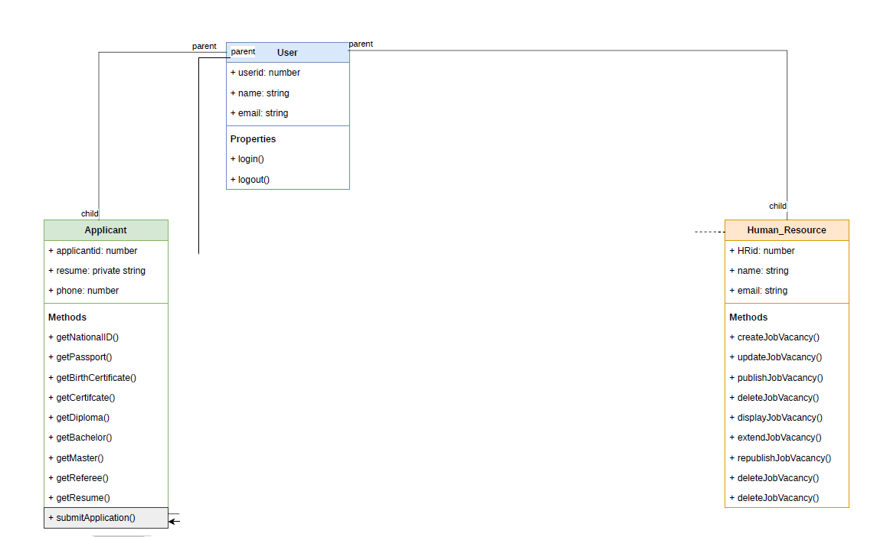

Identification of where encapsulation will be applied
As fare as private properties is concerned:
- Applicant resumes and personal data will be stored as private properties.
- Access controlled via getters/setters to ensure data privacy.

Proposed design pattern - Explanation/justification for the selected pattern
As we can see in the diagram above we have complex objects to create, for instance, organization will come with their requirement so therefore to comply with their requirement will have various types of application.
The appropriate design pattern to gather for that variety is Factory Method.
- Factory Method
  - Problem solved: Complex object creation (e.g., different types of applications or interview objects).
  - Why appropriate: Centralizes creation logic, avoids duplication, and makes it easy to extend new types of job applications later.
Another design pattern as we can see during the process of application State Pattern are to be used because, each application passes from one state to another. And creates other components.
- State Pattern
  - Problem solved: Managing application status transitions.
  - Why appropriate: Encapsulates each status (Submitted, Shortlisted, Interview Scheduled, Hired, Rejected) as a separate class, making transitions explicit and reducing conditional spaghetti code.
For instance if we see carefully, when the application got scored to be successful, then it creates other objects such as shortlistofcandidates etc…
- Observer Pattern
  - Problem solved: Event-driven updates when application status changes.
  - Why appropriate: Decouples the core application logic from dependent modules (notifications, dashboards, analytics). When status changes, observers are automatically notified.

- Mediator Pattern
  - Problem solved: Coordinating interview scheduling among multiple actors.
  - Why appropriate: Provides a central mediator to handle communication between candidate, recruiter, and manager without them directly referencing each other.

Initial JavaScript class structure
javascript
class User {
constructor(userId, name, email) {
this.userId = userId;
this.name = name;
this.email = email;
}
login() { /* ... */ }
logout() { /* ... */ }
}

class Applicant extends User {
constructor(userId, name, email, resume) {
super(userId, name, email);
this.#resume = resume; // encapsulated
}
submitApplication(job) { /* ... */ }
getResume() { return this.#resume; }
}

class Recruiter extends User {
shortlistCandidate(application) { /* ... */ }
notifyApplicant(applicant) { /* ... */ }
}

class Job {
constructor(jobId, title, description, requirements) {
this.jobId = jobId;
this.title = title;
this.description = description;
this.requirements = requirements;
this.status = "open";
}
closeJob() { this.status = "closed"; }
}

class Application {
constructor(applicationId, applicant, job) {
this.applicationId = applicationId;
this.applicant = applicant;
this.job = job;
this.status = "submitted";
this.observers = [];
}
addObserver(observer) { this.observers.push(observer); }
updateStatus(newStatus) {
this.status = newStatus;
this.observers.forEach(obs => obs.notify(this));
}
}

Initial Git/GitHub repository
To perform the Git/GitHub repository:
We create first a repository in GitHub. We use my account gtauanea
The link is here: https://github.com/gtauanearu/ITDI110OnlineJobRecruitment
Then; we open the terminal from Visual Studio Code on the folder that contain the project directory we run the following command:
>git init
>git add .
>git commit -am “Initial commit Checkpoint1”
>git remote add origin https://github.com/gtauanearu/ITDI110OnlineJobRecruitment
>git remote -v
>git push origin master

